
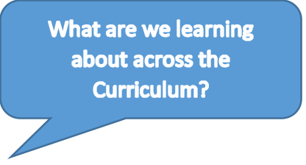
RE: Creation and Covenant
Stories from Genesis
Science: Living Things and their Habitats
How can we classify living things?
History: Ancient Greece
What were the ancient civilisations and how do the Greeks fit in the timeline of History.
Music: Songs from World War Two
DT: Structures: Children will be developing and building their own playground designs
RHE: Life to the Full: Calming the Storm. God loves and cares for us, We can bring our troubles to God and We can have faith in God.
P.E: Dodgeball – in Term 1 all classes will have PE on a Friday. Please ensure your children are correctly dressed.
We will continue to develop writing stamina and independence as these are key skills for Year 6 and beyond.
Children will be beginning to prepare for their SATs assessments in May and as such will complete their first round of practice papers. This will give their teachers the chance to notice any GAPs in knowledge and begin to address these.

Welcome to Term 1
Welcome back to St John’s and welcome to Year 6! This term we are reading the book ‘Friend or Foe’ by Michael Morpurgo. The children will be using the book to start develop their understanding of World War Two and Evacuation. The children will be using ideas from the texts to write diary entries, setting descriptions and balanced arguments. We will be continuing to learn how to enhance our sentences through the use of subordination and with higher level punctuation. In Maths, the children will develop their understanding of Place Value with numbers up to 10 million. They will develop their understanding of written methods for addition, subtraction and multiplication including decimal contexts. Every child will be provided with a Times Table Rockstars login so they can practise these skills at home. These will be given to the children so please look out for these.
Please remember that it is essential that the children are reading daily and parents should be questioning the children on their understanding of what they have read. On the Year 6 section of our school website, we have added examples of the sorts of questions you could be asking.

We are always happy to answer any questions you have regarding your child’s learning please reach out via the school office.
Mr Joyce, Mrs Nash, Mrs O’Connor and Ms Ludlow

What are we learning -
Reading:
Friend or Foe
Developing retrieval, inference and comparison skills.
Writing:
Prequal Writing – What happened before the egg discovery?
Diary Entries
Comparative Setting Descriptions
Balanced Arguments
Character Descriptions
Informal Letters
Handwriting:
Ensuring that children can maintain neat, legible, joined handwriting over a sustained period.

Maths:
Place Value of numbers to 10 million
Formal methods for addition and subtraction including decimals
Inverse Operation
Factors and Multiples
Written methods for multiplication.

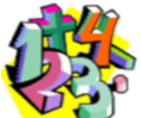
Monday: Children will bring a printed Spelling Shed exercise to be completed and returned on Tuesday. The words in this activity will then be tested weekly.
Tuesday: CGP Reading – children to complete a page from their books and return this on Wednesday.
Wednesday: CGP Maths – children to complete a page from their books and return this on Thursday.
Thursday: CGP Grammar and Punctuation – children to complete a page from their books and return this on Friday.

Daily: Children should be reading each day, using TTRS to develop their times table knowledge and learning their weekly spelling words.

In Year 6, we have been working incredibly hard. Below you can see some of the work we have created that is being displayed around the school. We contributed to the whole school writing display focussed around writing a prequel to the ‘Egg Discovery’. In English, we have been writing diary entries from the perspective of an evacuee and in RE, we have been looking at artistic representations of ‘The Fall’ story from Genesis.
